TC-CMS-020
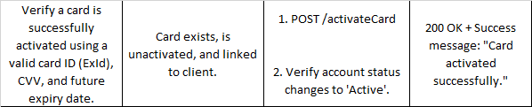
An existing Inactive Card
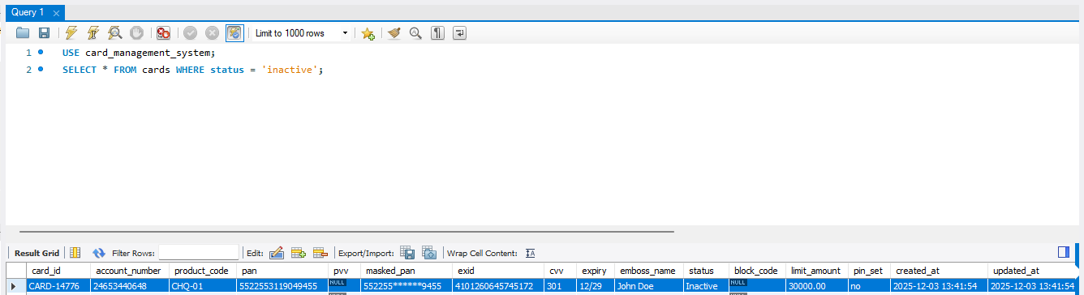
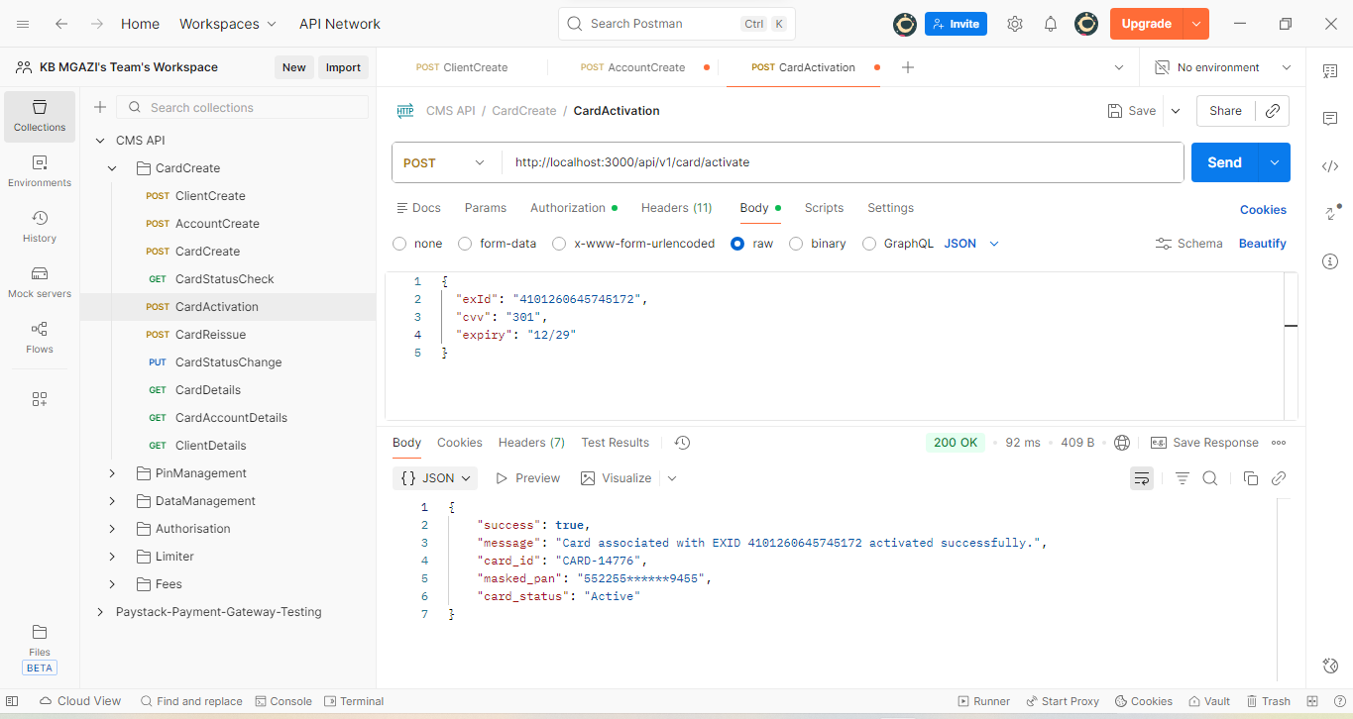
Request:
{
"exId": "4101260645745172",
"cvv": "301",
"expiry": "12/29"
}

Response:
{
"success": true,
"message": "Card associated with EXID 4101260645745172 activated successfully.",
"card_id": "CARD-14776",
"masked_pan": "552255******9455",
"card_status": "Active"
}

Card Successfully Activated
